# Deep Learning and Neural Networks

**Module 4**

**Table of Contents**

Learning Outcomes 5

Deep Learning and Neural Networks 1

Fundamentals of Artificial Neural Network 6

Review of AI Concepts 6

Artificial Intelligence 6

Supervised and Unsupervised Learning 6

Artificial Neural Networks 7

The Human Brain and the Neural Network 8

Machine Learning vs. Neural Network 10

Conclusion – Machine Learning vs. Neural Network 12

Deep Learning 13

Introduction to Deep Learning 13

Deep Learning v/s Machine Learning 16

Applications of Deep Learning 18

Real-time Speech Translation 18

Uses of a Translator App 20

Computer Vision 20

Object/Image classification using OpenCV Library 21

Natural Language Processing – Sentiment Analysis 22

Practical Assignments/Lab Work 23

Questions to Ponder Upon 24

Links for Further Reading 24

References 25

Glossary 28

**Disclaimer:**

The Imagine Cup Junior guides and lesson materials are created by Microsoft and our partners and intended to be for guidance only to support with the Imagine Cup Junior Challenge. For the latest on Microsoft AI please visit <https://www.microsoft.com/en-us/ai>

**Learning Outcomes**

This module will help students recap the topics studied in the previous modules such as artificial intelligence and machine learning.

The module touches upon the topic of neural networks – both artificial and human. It helps students to understand how the artificial network functions and the ways it trains itself to mimic human-like thought process. It focuses on activation functions and various other applications of deep learning. After the completion of this module, students will be able to

* Recall the basics of AI-related concepts.
* Understand supervised and unsupervised machine learning.
* Conduct a mapping of the various learnings that are classified under supervised and unsupervised machine learning.
* Comprehend the concept of working of the human brain and its similarities with the artificial neural network.
* Develop a working understanding of the neural network applications.
* Understand the similarities between deep learning and artificial intelligence.
* Appreciate the similarities and differences between machine learning and deep learning.
* Comprehend the working of sentiments analysis via natural language processing.

Fundamentals of Artificial Neural Network

# Review of AI Concepts

In earlier modules, we learnt about the different aspects of artificial Intelligence. In this module let us recap very briefly terms such as artificial intelligence, supervised learning and unsupervised learning.

# Artificial Intelligence

Artificial Intelligence (AI) is defined as the ability of a digital computer or computer-controlled device to perform tasks commonly associated with intelligent beings (Copeland, 2019). We have learnt in earlier classes that machines using in-built experiences that show a level of reasoning, learning capabilities, and discovering meaning and context are characteristics so typical of humans that they get labeled as machine learning capabilities. Artificial Intelligence as a science enables machines to carry out complex tasks with minimal human intervention in scenarios which may be threatening to the human life or are too complex or take too much time to solve by human beings.

One example of artificial Intelligence that can be observed in daily life is face recognition and its subsequent labeling on social media.

# Supervised and Unsupervised Learning

Supervised Learning algorithms are trained using labeled examples, from an input where the desired output is known. The learning algorithm receives a collection of inputs and the corresponding correct outputs and learns by comparisons between its actual output and previous correct outputs in order to identify errors, and modifies its model accordingly. Using strategies such as classification, regression, prediction and others, supervised learning uses patterns to predict the values of the label on unlabeled data. Supervised learning is usually employed in applications wherever historical knowledge can easily predict future events.

Unsupervised learning is used with data that has no historical labels and therefore cannot use these to help it learn. However, the dataset may contain a few data points that are labeled. The algorithm needs to compute and analyze based purely on this limited amount of labelled data available and learn how to automatically label those that are not. The goal is to explore the data and recognize some patterns contained within. Examples can be found in systems such as visual recognition, robotics and identifying human behavior.

Artificial intelligence is being used in various ways for the improvement of society using such techniques as gaming, natural language processing, expert systems, and vision systems to comprehend and describe visual computer input. It is also used in disciplines such as speech and handwriting recognition in designing devices which can follow human speech-based instructions.

# Artificial Neural Networks

By now we all know that machine learning is a subset of artificial intelligence, an area of science which enables a machine to learn from experience without having a person to program the machine explicitly. This enables the machine to learn from experience by simultaneously upgrading itself in terms of the learning complexities it encounters.

Whilst there are many models and algorithms that can be used for machine learning, the suitability of the model or algorithm is entirely based on the data used and the expected outcome. It is important that the models be understood to ensure ease of usability. In the machine learning domain, tasks can be classified into clear categories based on the way the learning is carried out. Two very well-known categories are

* Supervised learning
* Unsupervised learning

Inspired by the way the brain works and the structure of the brain, scientist have developed the concept of the neural network. The brain consists of small units known as neurons. These neurons communicate with each other to pass on information via something called synapses. Neural networks work in a similar way. In reality, a neural network is a group of algorithms which pass data between each other as it is processed. Such neural networks form a part of deep learning technologies.

# The Human Brain and the Neural Network

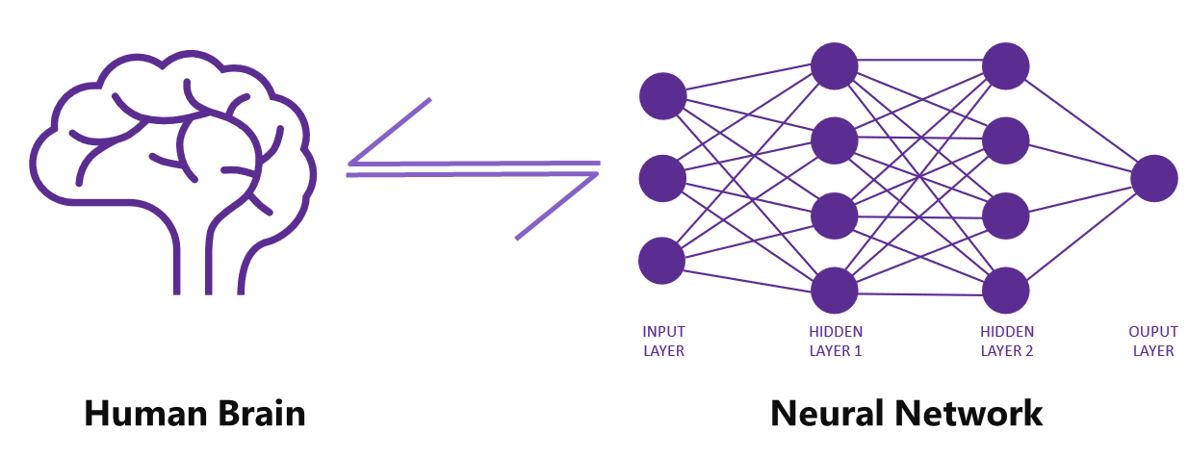

Fig 4.1: Similarities between a human brain and neural network

The human brain receives and transmits information via nerve cells (neurons). The human brain consists of many billions of neurons to form an elaborate network like structure. It is estimated that an average human brain consists of 86 billion neurons. The neurons in this dense network work in collaboration to ensure that the information needed to be passed on to the desired place, such as the muscle in your heart, is completed with the maximum speed and accuracy in order to allow your heart to pump at a particular rate depending on how much blood your body needs to be circulating at any one time.

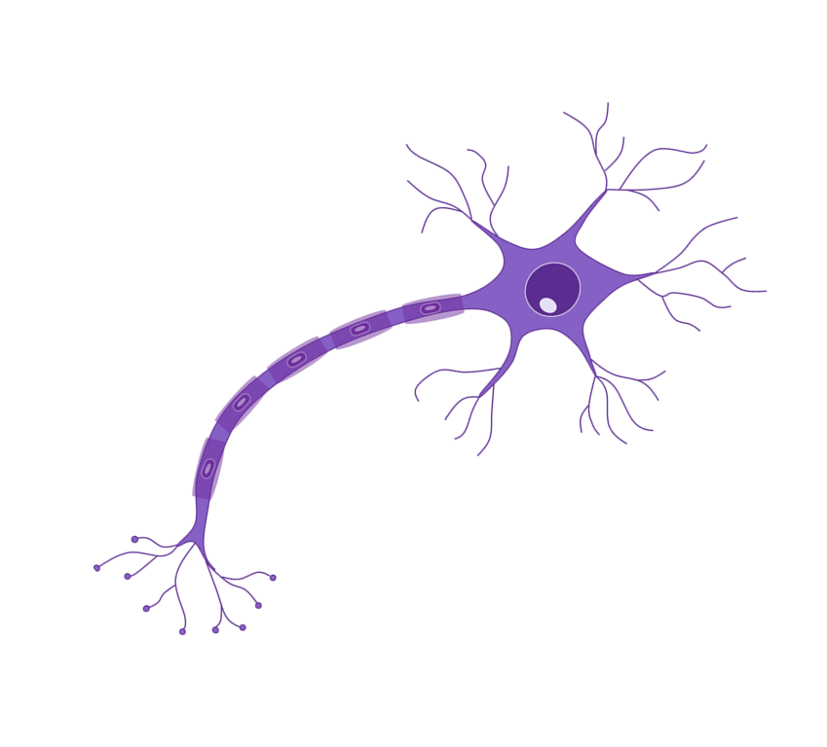

Fig 4.2: A neuron of the human brain

A neuron consists of three distinct parts: a cell body, a dendrite, and an axon. The cell body is the largest part of a neuron and consists of the nucleus and cytoplasm. Dendrites are extensions that are responsible for receiving messages from other neurons, and the axon is that part of a neuron that is responsible for sending the signals. These nerve cells pass on the information as electrical impulses to the adjacent cells via the synapse.

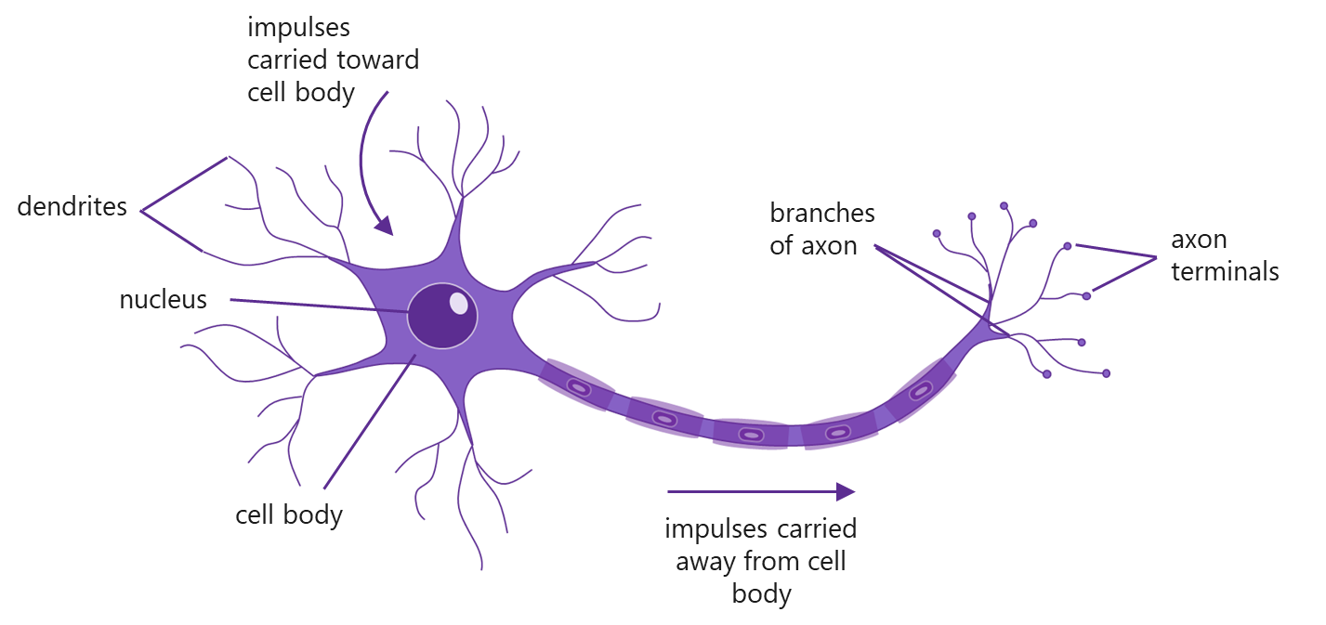

Fig 4.3: A neuron of the human brain

A similar concept is adopted for algorithms in machine learning. The ‘neurons’ in the neural network are artificially created in a computer and joined to other such ‘neurons’ present in the network. This creates the neural network. The artificial neuron imitates the working of a biological neuron.

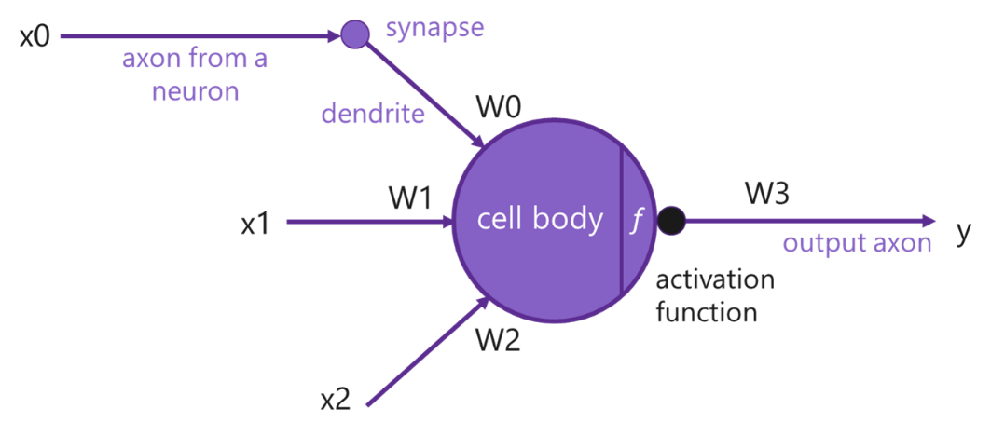

Fig 4.4: Artificial neuron of the neural network

# Machine Learning vs. Neural Network

Machine learning is defined as a set of algorithms that analyzes the data fed into the system and learns from the data to make informed decisions. However, a neural network is an advanced algorithm that can be used for machine learning with the in-built capability to learn and apply further. Whilst machine learning may require human intervention in some form especially when it encounters inaccuracy at any stage, a neural network will learn from its inaccuracies and take intelligent decisions on its own to rectify the same. A case in point is the NNI (Neural Network Intelligence) which is a toolkit designed to help users who run automated machine learning (AutoML) experiments (JiayueHu and Minewiskan, 2018).

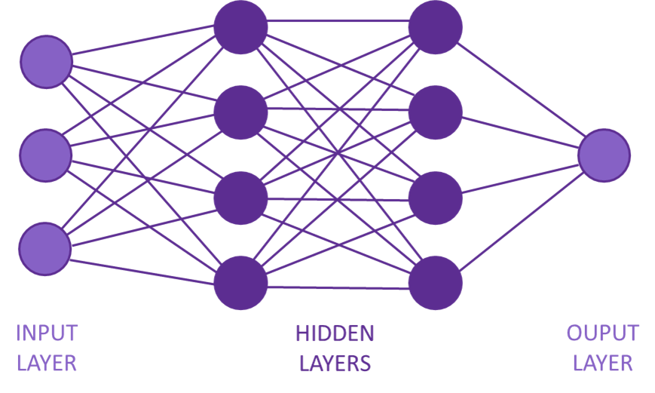

Fig 4.5: Multiple layers of a neural network (Image Source: (Marcus, 2018)

From an architecture point of view, a general neural network would consist of three layers namely the input layer at the start, the hidden layers in between and the output layer at the end.

**Machine Learning vs. Neural Network Comparison Table (Educba, 2019)**

|  |  |  |
| --- | --- | --- |
| Areas | Machine Learning | Neural Network |
| **Definition** | Machine Learning is a set of algorithms that uses parse data and learns from the parsed data and use those learnings to discover patterns of interest. | Neural Network or Artificial Neural Network is one set of algorithms used in machine learning for modeling the data using graphs of Neurons. |
| **Skills Required to Learn** | * Probability and Statistics * Programming Skills * Data structures and Algorithms * Knowledge about machine learning frameworks * Big data and Hadoop | * Probability and Statistics * Data modeling * Programming skills * Data structures and algorithms * Mathematics * Linear algebra and graph theory |
| **Applied Areas** | * Health Care * Retail * E-commerce * Online recommendations * Tracking price changes * Better customer service and delivery systems | * Finance * Health Care * Retailing * Machine learning * Artificial Intelligence * Stock Exchange Prediction |
| **Examples** | Siri, Bing Maps and Bing Search, etc. | Image Recognition, Image Compression, and Search engines etc. |

Table 4.1: Comparison between Machine Learning and Neural Networking

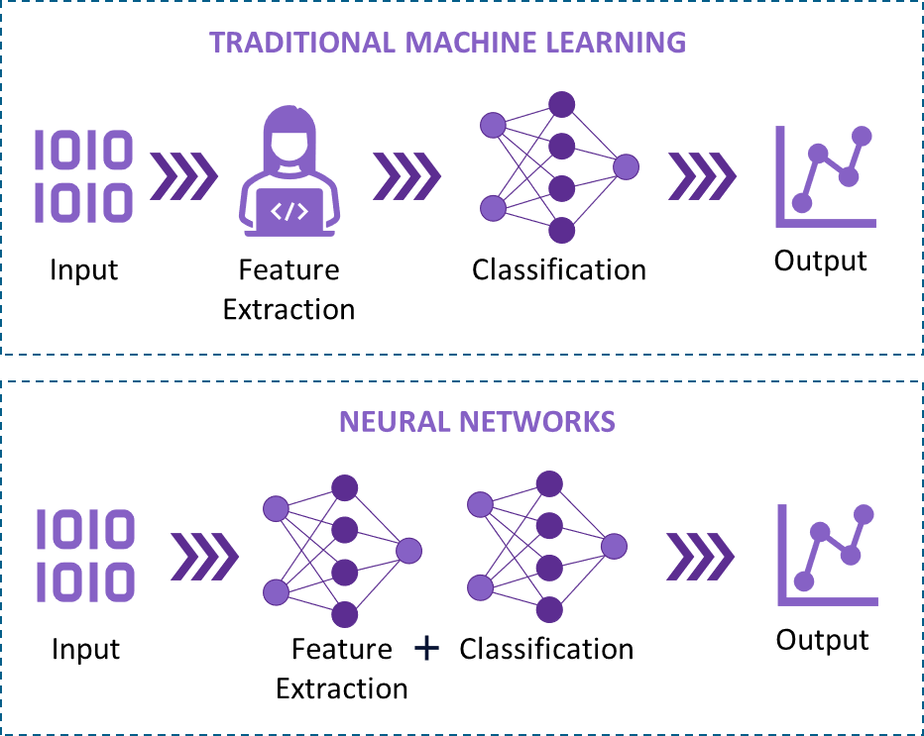

Fig 4.6: Diagrammatic Representation of Differences between Machine Learning & Neural Network

# Conclusion – Machine Learning vs. Neural Network

Whilst machine learning can be understood as the basic or the core discipline, neural networks or deep learning can be considered as a notch higher in terms of complexity whereby it enables the machine to ‘think like a human’ making intelligent and well-informed decisions.

It falls under the same field of Artificial Intelligence, whereby Neural Networks are a subfield of Machine Learning. Machine learning serves mostly from what it has learned, whereby neural networks are deep learning that powers the most human-like intelligence artificially. We can conclude by saying that neural networks or deep learning are the next evolution of machine learning. The technology enables the machine to learn from the past decisions and make its own decision without human intervention at any level in any form.

Deep Learning

# Introduction to Deep Learning

Deep Learning is a subfield of machine learning concerned with algorithms inspired by the structure and function of the brain and relies on neural networks.

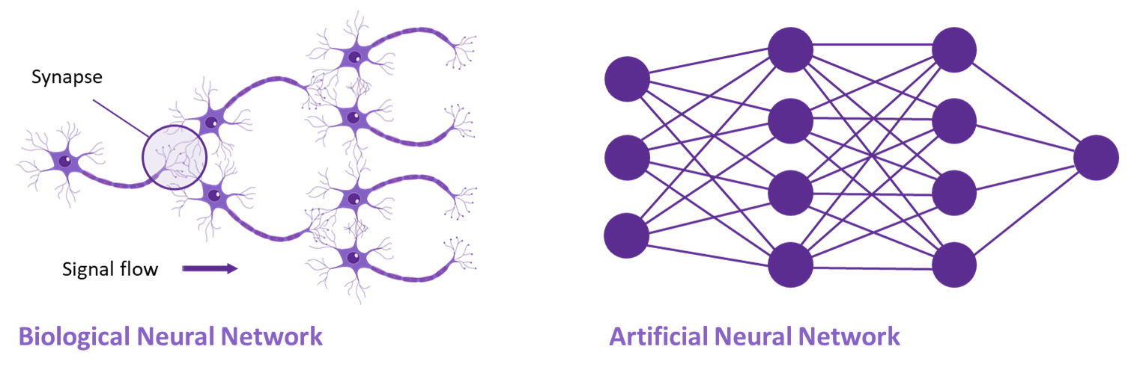

Fig 4.7: Similarities between a Biological and Artificial Neural Network

Andrew Yan-Tak Ng, a Chinese-American computer scientist and statistician who specializes in machine learning and AI, is of the opinion that “Deep learning has taken off like crazy is because it is fantastic at supervised learning. Almost all the value today of deep learning is through supervised learning or learning from labeled data”. In other words, a deep learning neural network primarily needs enormous amounts of labeled data and a quality supervised machine learning algorithm appropriate enough to generate the desired results.

The Deep Learning subset of AI is based on algorithms inspired in structure by components and the working of the human brain. Whilst many of you may confuse it with a neural network, there is a deeper connection. You have read in the earlier modules that supervised learning is the recommended form of machine learning as it tells the machine what needs to be done and how. The entire path is defined for the machine to study, learn and follow.

However, deep learning is different as the algorithms used have an in-built learning capability. These algorithms work on similar processes to those in human brains, such as being able to identify connections between the data points, learn on their own, and find out what can be done to arrive at the result, even when the data is unsupervised.

Deep learning algorithms are programmed to do what we as humans are programmed naturally to do internally. The ability to learn by example is inherent in humans and at times, we humans may not be able to achieve the accuracy that a machine may be able to deliver. The deep learning algorithms are able to use unsupervised data to form a pattern and are programmed in the initial (training) stages by large sets of labeled data and many, multi-layered, neural network architectures.

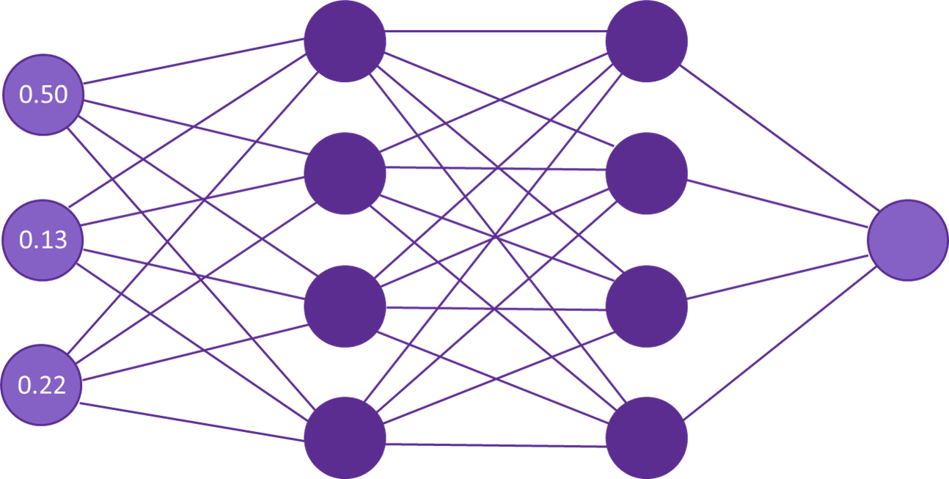

Fig 4.8: A neural network receiving data represented as numbers

In a neural network, data is represented as numbers. Pretty much anything can be converted to a number, for example, a sound wave can be represented as the amplitude taken at different samples and an image can be represented by the brightness levels of each individual pixel (see fig 4.9).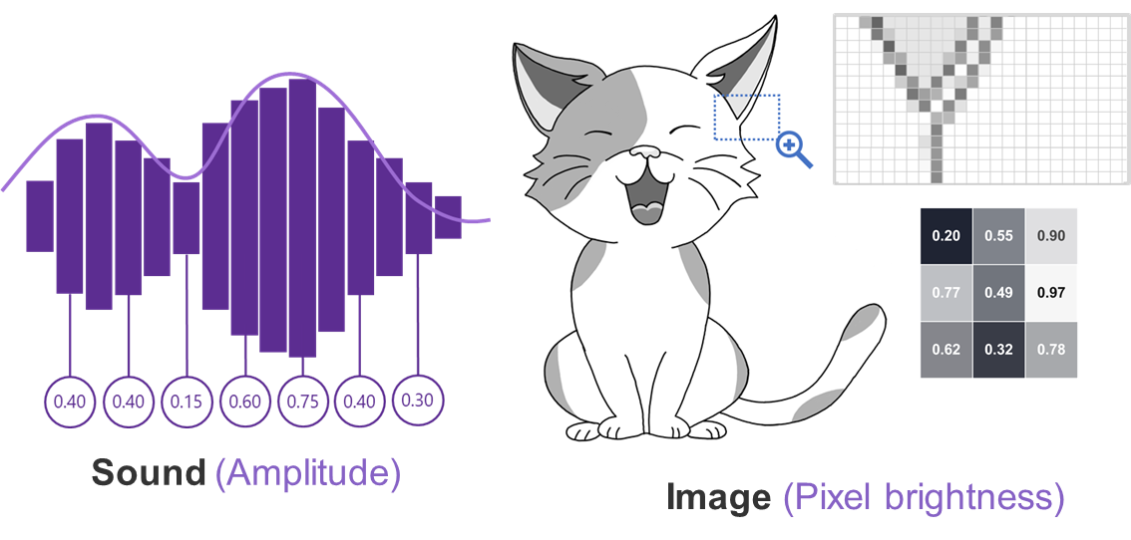

Fig 4.9: Example of how sound and images can be represented as a number

#### Greyscale image

In a greyscale image, each feature contains information on how bright each pixel is rather than colour.

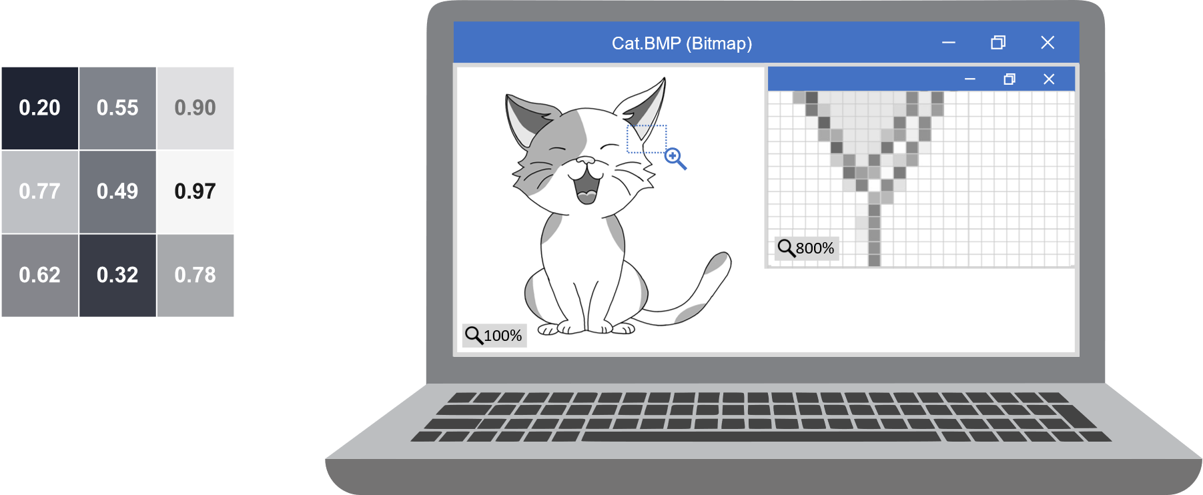

Fig 4.10: A greyscale image represented as numbers

#### Color image

In a color image, we can represent each pixel with 3 numbers defining the amount of red, green and blue primary colors in that pixel.

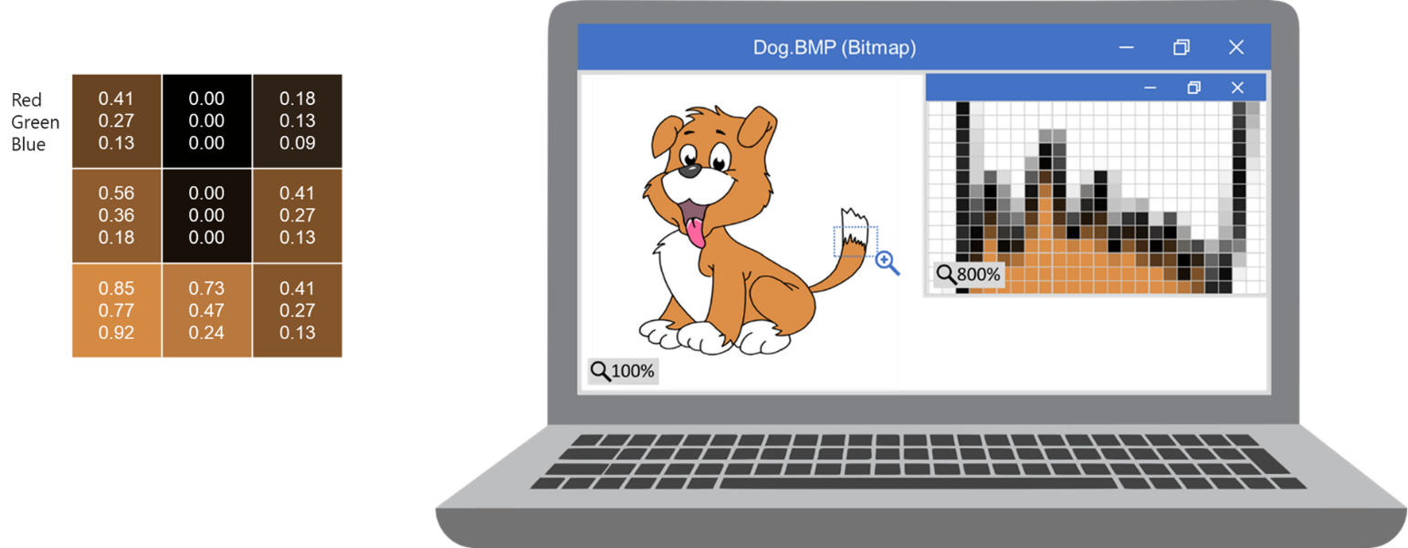

Fig 4.11: A color image represented as numbers

# Deep Learning v/s Machine Learning

Machine Learning is a set of algorithms that have the capability to analyze the data provided, learn from that data, and apply what is learnt to make intelligent decisions. Many prominent examples can be found on social media, and photo storage platforms which are capable of identifying people from unloaded images, or recommending movie and television program based on what you have watched via a streaming app. This learning is based on the past actions, selections and preferences of the user. Machine learning may need human intervention at times and tend to perform limited tasks for what they have been programmed as it does not think beyond the realms of what it has been programmed for and subsequently learnt to do within those realms.

Deep learning contains a complex hierarchy of concepts, each one defined and related to the other in some form of the other. The development of a deep learning technique involves the processing of the data through various layers through a step-by-step process. Among the various benefits of using deep learning techniques, the two most prominent ones are:

* Scalability - ability of a computing process to be used across a range of applications.
* Feature Learning - ability to perform automatic feature extraction from raw data

Deep learning machines tend to require enormous amounts of data as well as high-end computers to generate the desired results. A graphics processing unit, or GPU, is also an integral part of a deep learning system in order to process images in parallel with computations on data.

Whilst both machine learning and Deep Learning are subsets of AI, their approaches to solving a problem are completely different from each other. Let us see how. Here is an image containing a mixture of cats and dogs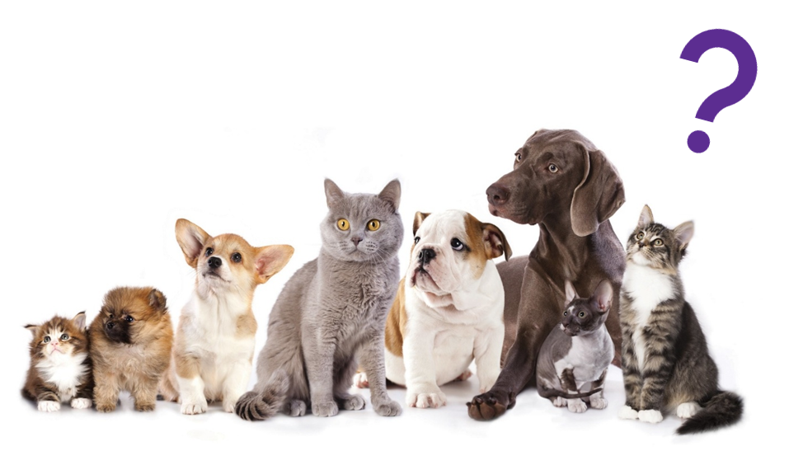  
Fig 4.12: A collective image of dogs and cats (Image Source: Kaggle)

The goal of the neural network is to measure whether the input data contains certain features, for example, a curve or point in the edge of the image suggesting the presence of an ear or a particular cluster of colors signifying a possible whisker.

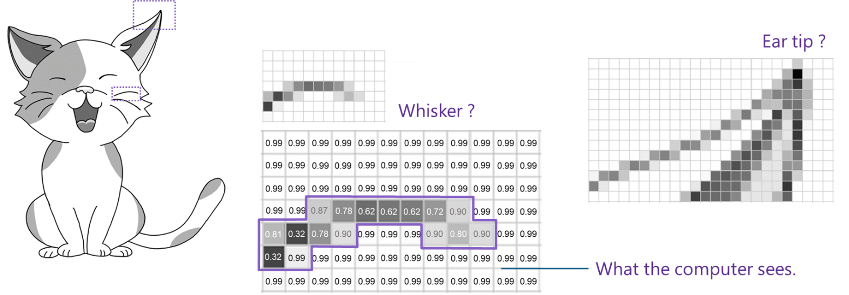

Fig 4.13: Example of what the computer sees

Each node in the neural network translates these features into numbers which it uses to determine the output which, in the example below (fig 4.14), is whether the input image is of a cat or a dog.

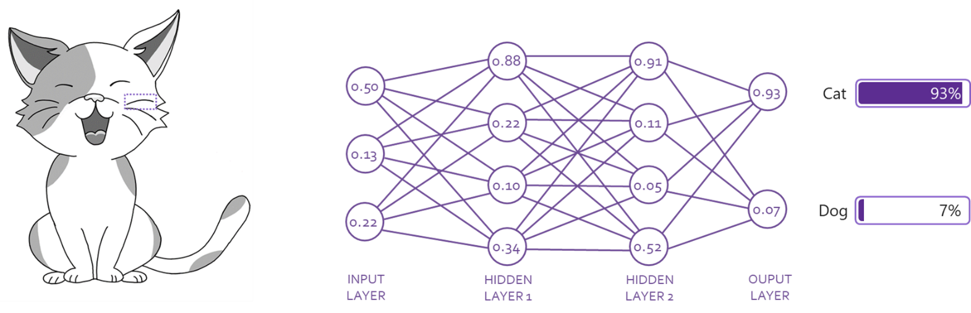

Fig 4.14: A neural network determining if a picture is of a cat or a dog

Applications of Deep Learning

**Day-to-day applications**

Whilst deep learning may sound like an advanced concept, the fact is that it is very much a reality and has many day-to-day applications. Deep learning applications are applied in the following areas:

* Self-driving automobiles
* NLP (Natural Language processing)
* Fraud detection in the Banking sector
* Restoration of colors in vintage images and videos
* Disease diagnosis in healthcare

# Real-time Speech Translation

Have you ever seen an ongoing session of the UN General Assembly or European Parliament on the television or video? You will see that many members wear headsets during the session. The headsets are a part of an Interpretation Service which provides the member with real time translation services.

The staff of the Interpretation Service are thus responsible for ensuring that members, and others, present at a meeting are able to understand what is being said, and at the exact time that they are speaking. They provide simultaneous interpretation from and into the official languages for meetings.

Fig 4.15: UN Members using headphones during the General Assembly session. Source - (Haughton, 2019)

One of the biggest challenges that a linguistically distinct team may face in such a scenario is that of the language. However, it is no longer a challenge anymore as real time speech translation services tend to act as ‘go-to medium’ for people to hold a conversation using different languages.

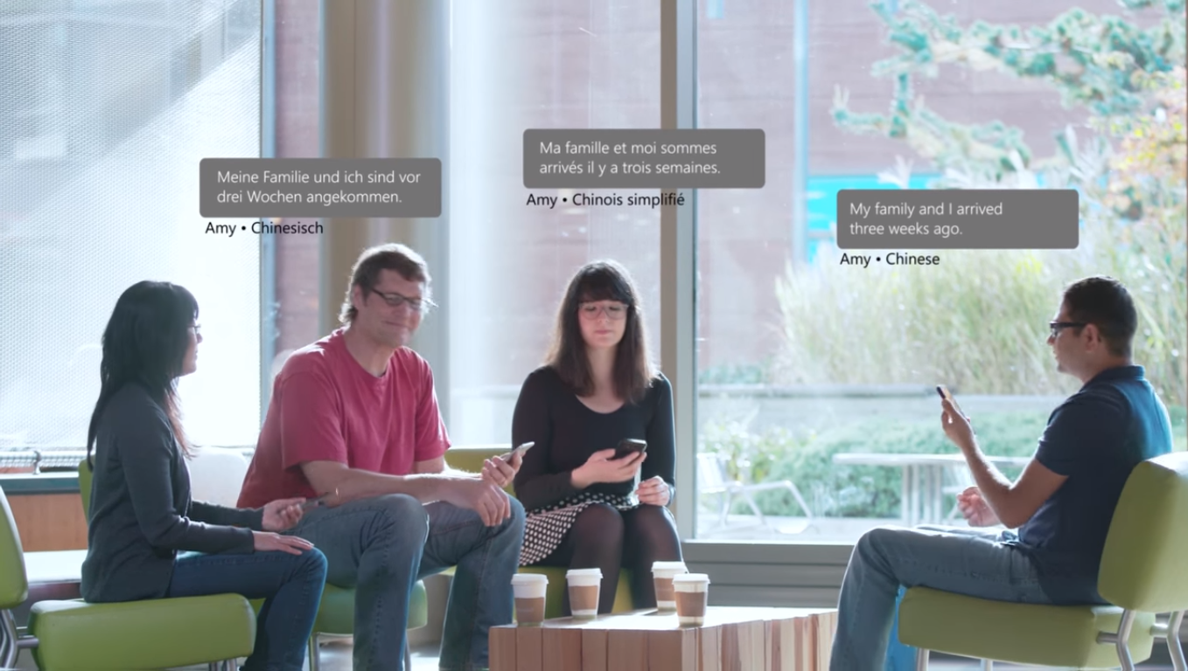

Fig 4.16: Words being interpreted by others in their own languages using the translator app Source - (Microsoft and Hughes, 2016)

Language is the thing that bonds us all together and one of the most successful ways AI helps humankind is by removing the barrier of language between people of difference nationalities. Microsoft Translator, and similar products, have been created with the aim of breaking the language barrier and creating a personal interpreter for people who travel often or meet people from other cultures speaking different languages.

# Uses of a Translator App

Whilst a primary function of a translator can translate text entered into a text box in the desired language, they also accomplish the following goals:

* Enable participants to share experiences in their native language.
* Teachers are able to present to a wider audience.
* Enables easier travelling and in meeting people internationally.
* Make people feel welcome.

Of course, the translator system not only receives input as text but as mentioned earlier can extract text from images and voice and also output as such. This means an entire conversation can be held verbally between two or more people who don’t speak the same language.

# Computer Vision

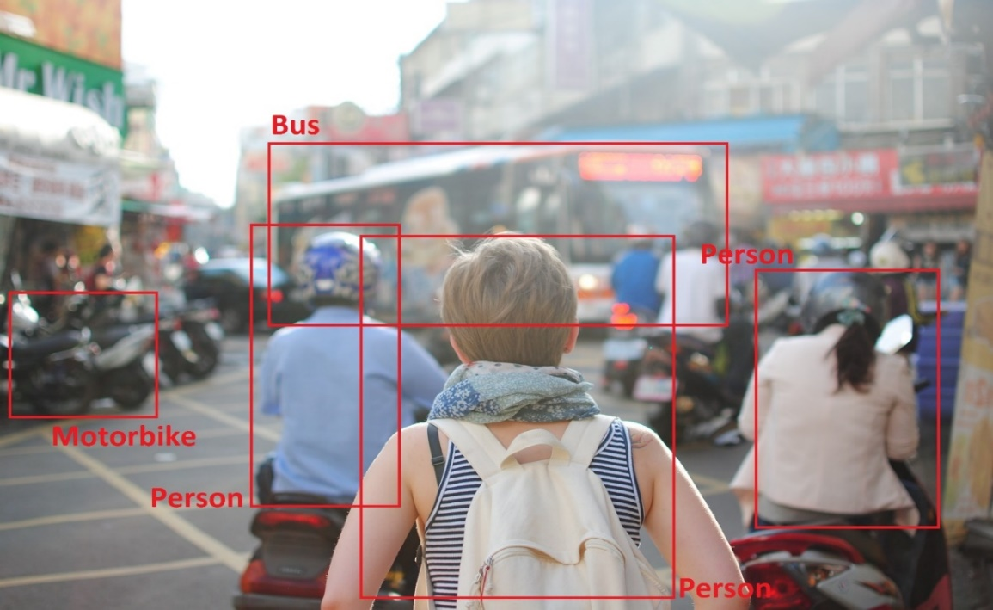

Fig 4.17: A visual representation of Computer Vision  
Credit: Steven Lewis (Image Source: <https://unsplash.com/photos/r4He4Btlsro>)

The ability to look at things and perceive them as objects we define is a quality that makes us unique. Human beings look and understand the value and meaning of many objects and in different contexts. Computer vision is similar. It is defined as the ability of a machine to be able to capture, identify and process images.

From the human perspective, recognizing objects around us is not difficult but from the perspective of a machine it is difficult. This is because it does not have the expertise and as such needs to build that expertise from scratch. Once created, the machine can revisit data it has learnt from data points provided over time in order to arrive to a conclusion based on the inputs.

OpenCV, or Open Source Computer Vision library, originally started out as an Intel research project and is the largest computer vision library to date as it contains a massive amount of computer functions that can be used to program machines. It contains an implementation-based bank of more than 2500 algorithms. These libraries are free to use and are often used for both commercial and academic purposes. One of the many features of OpenCV is that the library has interfaces for languages which include Python, Java, and C++. In other words, it is a robust platform that can create any application using in any of the languages. The first OpenCV version, 1.0, was released in 2006 and the OpenCV community has grown since then.

# Object/Image classification using OpenCV Library

The process of classifying images as separate groups to facilitate labeling is called classification of the images. The process of object categorization programs the classifier to recognize categories of objects using only the images which have been retrieved automatically. The process is extensive and is carried out in 3 steps.

**Step 1 – Pre-processing**

This step begins by making the images noise free. It uses processing pre-processing the images to clear the slightest hint of noise in them.

**Step 2 – Splitting the dataset**

In this step a small batch of images are used during various iterations of the optimizer. This speeds up the training time required.

**Step 3 – Building a Convolutional Neural Network**

This step can have 3 convolution layers with 2 x 2 max-pooling. Max-pooling is primarily a technique which is used to reduce the dimensions of a given image by taking the maximum pixel value of a grid. In other words, 2x2 pixels

# Natural Language Processing – Sentiment Analysis

Recall a time when you last communicated with someone on social media and used an emoticon rather than writing any text. Have you ever participated in an online poll? Did you ever wonder how prediction works on a social site? With mere emoticons as the mode of expression how is the webpage able to understand whether your statement is positive, negative or neutral?

The analysis of data on company social media website gathers two pieces of data:

* Sentiment analysis
* Count based metrics

The importance of sentiment analysis from a commercial point of view is:

* Comprehending the key aspects of a brand’s products and services where customers have highlighted their concerns.
* Capturing the reaction of the customer feedback
* Understanding the main buying behavior of the customer

Sentiments, both positive and negative, are the most significant way of expressing user opinions via social media. Emotions are often used as the best data set through to which communicate the choices of the customer and defines their choices. This makes Natural Language Processing (NLP) quite important in the analysis of the sentiments. NLP uses both speech analysis and social media monitoring to understand customer reaction. Improving the customer experience and helping to achieve a speedy resolution helps in changing the market position of the company.

For example, if a customer sends an email about a problem they’re experiencing with a product or service, an NLP system would recognize the customer emotion (angry, disappointed, annoyed etc.) and mark it for a quick automatic response, or for example, forward the email to the right person based on the level of anger.

Practical Assignments/Lab Work

Give examples of both supervised and unsupervised learning

* <https://www.geeksforgeeks.org/supervised-unsupervised-learning/>

Compare and contrast the human brain and artificial neural network.

* <https://www.analyticsindiamag.com/neural-networks-not-work-like-human-brains-lets-debunk-myth/>
* <https://towardsdatascience.com/ibm-draws-inspiration-from-the-human-brain-to-build-better-neural-networks-ed41ace864b1>

## Activity

Create groups preferably in a size of 3-5 students. Pick a movie scene of your choice and write down the dialogues in a standard screenplay format using the following link as a template

* <https://www.wikihow.com/Write-a-Screenplay>

Translate the script of the chosen scene from the film, then dub over the scene itself in the new language. The task can translate different sections of the text, over the app and then regroup to connect their parts into a full text, in different languages. Students can choose any language of their choice for discussion and translation.

Note: Signs can be particularly interesting to translate.

## Assignment

In pairs, review the video below on how Microsoft’s Immersive Reader is now available in Minecraft.

* [Video: Immersive Reader in Minecraft Education](https://youtu.be/BkmFIpSDJ7A)

Refer back to the Minecraft Hour of Code activity in Module 1 and log into Minecraft and explore using Immersive Reader within Minecraft. Test its features. Consider the features of the AI systems you can see on the demonstration. Using the knowledge gained from the course discuss with your partner what particular AI systems has Microsoft used with Immersive Reader being able to work in Minecraft.

Activity

Taking what you learnt about the Immersive Reader in Minecraft Education, review this video and then take on the challenge of creating an animation about the Three Little Pigs story. Use the Immersive Reader capability to translate this into at least 5 other languages.

* [Video: 3 Little Pigs Challenge – using Immersive Reader in Minecraft Education](https://youtu.be/C6ui_S337og)

Questions to Ponder Upon

What according to you can be the challenges in using huge amounts of data?

* <https://www.datamation.com/big-data/big-data-challenges.html>

Links for Further Reading

Microsoft Translator Service

* <https://www.hispanicmarketinfo.com/microsoft-ai-translator/>

The UN Interpretation Service

* <https://www.un.org/Depts/DGACM/interpretation.shtml>

10 Powerful Examples of AI Applications

* <https://becominghuman.ai/10-powerful-examples-of-ai-applications-553f7f062d9f>

Real-life examples of Machine Learning

* <https://bigdata-madesimple.com/top-10-real-life-examples-of-machine-learning/>

Why AI Fails

* <https://simplicable.com/new/machine-logic>

A Beginner's Guide to Understanding Convolutional Neural Networks

* <https://adeshpande3.github.io/A-Beginner%27s-Guide-To-Understanding-Convolutional-Neural-Networks/>

Boltzmann Machines

* [https://medium.com/@neuralnets/boltzmann-machines-transformation-of- unsupervised-deep-learning-part-1-42659a74f530](https://medium.com/@neuralnets/boltzmann-machines-transformation-of-%20unsupervised-deep-learning-part-1-42659a74f530)

Sentiment Analysis

* [https://towardsdatascience.com/sentiment-analysis-concept-analysis-and- applications-6c94d6f58c17](https://towardsdatascience.com/sentiment-analysis-concept-analysis-and-%20applications-6c94d6f58c17)

References

* Anonymous (2019). Available [online] at: <http://www.uta.fi/sis/tie/neuro/index/Neurocomputing2.pdf> [Accessed 25 Nov 2019].
* BrainFacts (2012). The Neuron. Brainfacts.org. Available [online] at: <https://www.brainfacts.org/brain-anatomy-and-function/anatomy/2012/the-neuron> [Accessed 25 Nov 2019].
* Brownlee, J. (2016). Supervised and Unsupervised Machine Learning Algorithms. Machine Learning Mastery. Available [online] at: [https://machinelearningmastery.com/supervised-and-unsupervised-machine-learning-algorithms](https://machinelearningmastery.com/supervised-and-unsupervised-machine-learning-algorithms/)/ [Accessed 25 Nov 2019].
* Brownlee, J. (2019). Deep Learning & Artificial Neural Networks. [online] Machine Learning Mastery. Available at: <https://machinelearningmastery.com/what-is-deep-learning/> [Accessed 25 Nov 2019].
* Cherry, K. (2019). Comparing the Amount of Neurons in Human and Different Animal Brains. Verywell Mind. Available [online] at: <https://www.verywellmind.com/how-many-neurons-are-in-the-brain-2794889> [Accessed 25 Nov 2019].
* Copeland, B. (2019). Artificial intelligence | Definition, Examples, and Applications. [online] Encyclopedia Britannica. Available [online] at: <https://www.britannica.com/technology/artificial-intelligence> [Accessed 25 Nov 2019].
* Debarko (2018). RNN or Recurrent Neural Network for Noobs. [online] Hackernoon.com. Available at: <https://hackernoon.com/rnn-or-recurrent-neural-network-for-noobs-a9afbb00e860> [Accessed 2 Dec 2019].
* Deshpande, A. (2019). A Beginner's Guide to Understanding Convolutional Neural Networks. [online] Adeshpande3.github.io. Available at: [https://adeshpande3.github.io/A-Beginner%27s-Guide-To- Understanding-Convolutional-Neural-Networks/](https://adeshpande3.github.io/A-Beginner%27s-Guide-To-Understanding-Convolutional-Neural-Networks/) [Accessed 2 Dec 2019].
* Educba (2019). Machine Learning vs Neural Network | Best 5 Useful Comparison. [online] EDUCBA. Available at: https://[www.educba.com/machine-learning-vs-neural-network/](https://www.youtube.com/watch) [Accessed 2 Dec 2019].
* Gupta, D. (2017). Fundamentals of Deep Learning - Activation Functions and their use. [online] Analytics Vidhya.com. Available at: [https://www.analyticsvidhya.com/blog/2017/10/fundamentals- deep-learning-activation-functions-when-to-use-them/](https://www.analyticsvidhya.com/blog/2017/10/fundamentals-deep-learning-activation-functions-when-to-use-them/) [Accessed 2 Dec 2019].
* Gupta, S. (2018). Sentiment Analysis: Concept, Analysis and Applications. [online] TowardsDataScience.com. Available at: <https://towardsdatascience.com/sentiment-analysis-concept-analysis-and-applications-6c94d6f58c17> [Accessed 2 Dec 2019].
* Guru99 Homepage (2019). Keras Tutorial for Beginners with Python: Deep Learning EXAMPLE. [online] Guru99.com. Available at: <https://www.guru99.com/keras-tutorial.html> [Accessed 2 Dec 2019].
* JiayueHu and Minewiskan (2018). Neural Network Intelligence - Microsoft Research. [online] Microsoft Research. Available at: [https://www.microsoft.com/en-us/research/project/neural-network- intelligence/](https://www.microsoft.com/en-us/research/project/neural-network-intelligence/) [Accessed 2 Dec 2019].
* Kapoor, A. (2019). Deep Learning vs. Machine Learning: A Simple Explanation. [online] Hackernoon.com. Available at: [https://hackernoon.com/deep-learning-vs-machine-learning-a-simple- explanation-47405b3eef08](https://hackernoon.com/deep-learning-vs-machine-learning-a-simple-explanation-47405b3eef08) [Accessed 2 Dec 2019].
* Kaur, M. (2019). Top 10 real-life examples of Machine Learning. [online] Big Data Made Simple. Available at: <https://bigdata-madesimple.com/top-10-real-life-examples-of-machine-learning/> [Accessed 2 Dec 2019].
* Keras Homepage (2019). Home - Keras Documentation. [online] Keras.io. Available at: <https://keras.io/> [Accessed 2 Dec 2019].
* Kurt (2019). Top 10 Applications of Machine Learning | Daily Life Applications | Edureka. [online] Edureka. Available at: <https://www.edureka.co/blog/machine-learning-applications/#dynamic-pricing> [Accessed 2 Dec 2019].
* Li, S., Li, W., Cook, C., Zhu, C. and Gao, Y., (2018). Independently recurrent neural network (IndRNN): Building a Longer and Deeper RNN. In Proceedings of the IEEE Conference on Computer Vision and Pattern Recognition (pp. 5457-5466).
* Mahapatra, S. (2018). Why Deep Learning over Traditional Machine Learning? [online] Towards Data Science. Available at: [https://towardsdatascience.com/why-deep-learning-is-needed-over-traditional- machine-learning-1b6a99177063](https://towardsdatascience.com/why-deep-learning-is-needed-over-traditional-machine-learning-1b6a99177063) [Accessed 2 Dec 2019].
* Marcus, G. (2018). Deep Learning: A Critical Appraisal. [image] Available at: <https://www.experfy.com/blog/the-limits-and-challenges-of-deep-learning> [Accessed 2 Dec 2019].
* Microsoft (2019). Microsoft Translator live - Microsoft Translator for Business. [online] Microsoft Translator for Business. Available at: <https://www.microsoft.com/en-us/translator/business/live/> [Accessed 21 Aug. 2019].
* Microsoft, M. and Hughes, O. (2016). Discover the new Microsoft Translator. [video] Available at: [https://www.youtube.com/watch?v=dv39UZSfsKw](https://youtu.be/dv39UZSfsKw) [Accessed 2 Dec 2019].
* Pal, S. (2019). 16 Awesome OpenCV Functions for your Computer Vision Project!. [online] Analytics Vidhya. Available at: [https://www.analyticsvidhya.com/blog/2019/03/opencv-functions-computer- vision-python/](https://www.analyticsvidhya.com/blog/2019/03/opencv-functions-computer-vision-python/) [Accessed 2 Dec 2019].
* Panchal, S. (2018). Artificial Neural Networks — Mapping the Human Brain. [online] Medium. Available at: [https://medium.com/predict/artificial-neural-networks-mapping-the-human-brain- 2e0bd4a93160](https://medium.com/predict/artificial-neural-networks-mapping-the-human-brain-2e0bd4a93160) [Accessed 2 Dec 2019].
* Saha, S. (2018). A Comprehensive Guide to Convolutional Neural Networks — the ELI5 way. [online] TowardsDataScience.com. Available at: [https://towardsdatascience.com/a-comprehensive-guide-to- convolutional-neural-networks-the-eli5-way-3bd2b1164a53](https://www.learnopencv.com/age-gender-classification-using-opencv-deep-learning-c-python/) [Accessed 2 Dec 2019].
* Selvamanikkam, M. (2019). Introduction to Artificial Intelligence. [online] Medium. Available at: [https://becominghuman.ai/introduction-to-artificial-intelligence-5fba0148ec99](https://www.geeksforgeeks.org/supervised-unsupervised-learning/) [Accessed 2 Dec 2019].
* Sennaar, K. (2019). Machine Learning for Medical Diagnostics – 4 Current Applications | Emerj. [online] Emerj. Available at: [https://emerj.com/ai-sector-overviews/machine-learning-medical-diagnostics-4- current-applications/](https://emerj.com/ai-sector-overviews/machine-learning-medical-diagnostics-4-current-applications/) [Accessed 2 Dec 2019].
* Spacey, J. (2017). 3 Examples of Unsupervised Learning. [online] Simplicable. Available at: <https://simplicable.com/new/unsupervised-learning> [Accessed 2 Dec 2019].
* Teacher, B. (2019). The Nervous System. [online] Leavingbio.net. Available at: <http://leavingbio.net/nervous-system/> [Accessed 2 Dec 2019].
* TensorFlow Homepage (2019). TensorFlow Core. [online] TensorFlow.org.
* Available at: <https://www.tensorflow.org/tutorials> [Accessed 2 Dec 2019].
* Unknown (2019). Neural Network Bias: Bias Neuron, Overfitting and Underfitting - MissingLink.ai. [online] MissingLink.ai. Available at: [https://missinglink.ai/guides/neural-network-concepts/neural- network-bias-bias-neuron-overfitting-underfitting/](https://missinglink.ai/guides/neural-network-concepts/neural-%20network-bias-bias-neuron-overfitting-underfitting/) [Accessed 2 Dec 2019].
* Unknown (2019). What Is Deep Learning? | How It Works, Techniques & Applications. [online] Mathworks.com. Available at: [https://www.mathworks.com/discovery/deep-learning.html](https://uk.mathworks.com/discovery/deep-learning.html) [Accessed 2 Dec 2019].
* Venkatachalam, M. (2019). Recurrent Neural Networks. [online] TowardsDataScience.com. Available at: <https://towardsdatascience.com/recurrent-neural-networks-d4642c9bc7ce> [Accessed 2 Dec 2019].

Glossary

**Activation:** The action or process of making something active or operative.

**Algorithm:** A process or set of rules to be followed in calculations or other problem-solving operations, especially by a computer.

**API:** A set of functions and procedures allowing the creation of applications that access the features or data of an operating system, application, or other service.

**Collaborate:** The act of work jointly on an activity or project.

**Convolutional:** One of the irregular ridges on the surface of the brain and especially of the cerebrum of higher mammals. A complication or intricacy of form, design, or structure.

**Data Mining:** The practice of examining large pre-existing databases to generate new information.

**GUI**: Graphical user interface is a form of user interface that allows users to interact with electronic devices through graphical icons and visual indicators such as secondary notation, instead of text-based user interfaces, typed command labels or text navigation.

**Integrated:** With various parts or aspects linked or coordinated.

**Medical Diagnosis:** The process of determining which disease or condition explains a person's symptoms and signs.

**Non-Trivial:** Important

**Parse:** An act of parsing a string or a text.

**Recurrent:** In relation to a nerve or blood vessel, turning back to reverse direction. Occurring often or repeatedly.

**Subset:** A part of a larger group of related things.

**Synapse:** A junction between two nerve cells, consisting of a minute gap across which impulses pass by diffusion of a neurotransmitter.

**Temporal Dynamic:** A periodic regularity, or, a one-off or irregular past, present or future of a particular element (e.g., word, topic or query popularity) - driven by predictable and unpredictable time-based events and phenomena.

